

SIMATS ENGINEERING

Saveetha Institute of Medical and Technical Sciences
Chennai- 602105

Student Name: A. Pavithra Reg. No.: 192424347
Course Code: DSA0615 Slot: A
Course Name: Data Handling & Visualization for Data Analytics
Course Faculty: Dr. Kumaragurubaran T & Dr. Senthilvadivu
Project title: Eco sense - Smart air quality monitoring dashboard
Module Photographs:
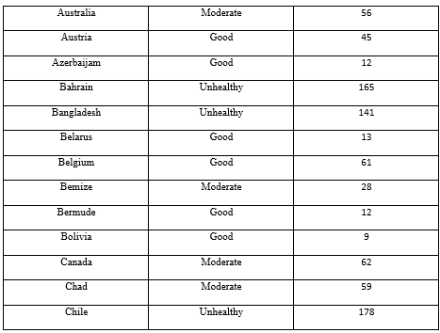
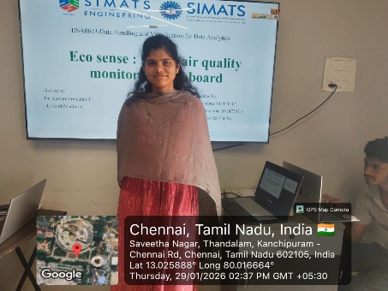
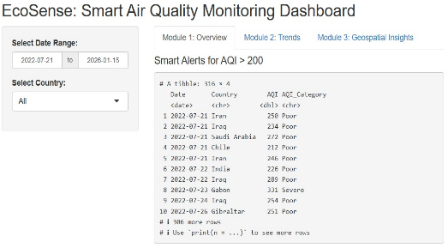
Project Description:
The Air Quality Overview & Pollutant Distribution module is a core component of the Eco Sense – Smart Air Quality Monitoring Dashboard, designed to provide a comprehensive, real-time view of environmental air conditions. This module focuses on collecting, organizing, analyzing, and visualizing air quality data so that users can easily understand pollution levels and their distribution patterns.
The module continuously gathers data from multiple air quality sensors deployed in the monitoring environment. These sensors measure key atmospheric parameters such as particulate matter (PM2.5 and PM10), carbon dioxide (CO₂), temperature, humidity, and other pollutant indicators. Once collected, the data is transmitted to the processing system where it is filtered to remove noise, validated for accuracy, and structured into standardized formats. This ensures reliable and consistent measurements, even when handling large volumes of streaming sensor data in real time.
After preprocessing, the module performs pollutant distribution analysis to identify patterns, trends, and irregularities in air quality. Statistical techniques are used to compare current readings with historical baselines, enabling the system to detect abnormal pollution spikes or unusual environmental changes.

Student Signature Guide Signature

